Setting up email onto iphone or ipad
- settings
- Go to mail, contacts, calendar
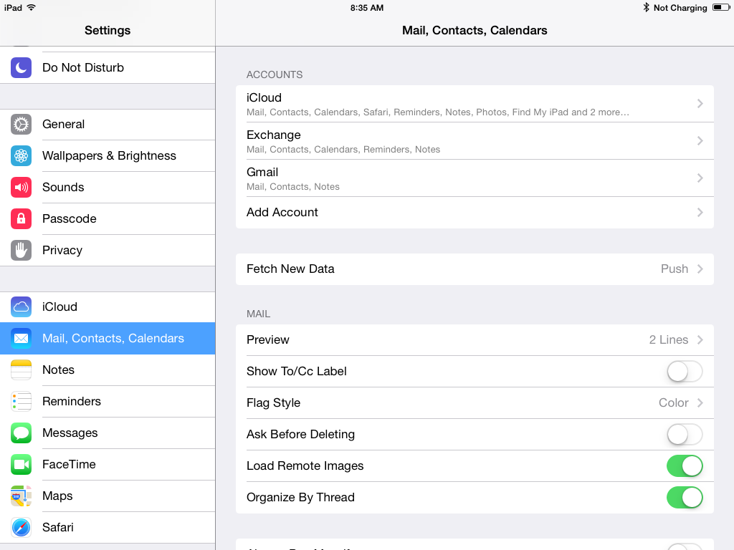
- Select add account
- Select Exchange
  - Input email address, password, and description. Hit Next
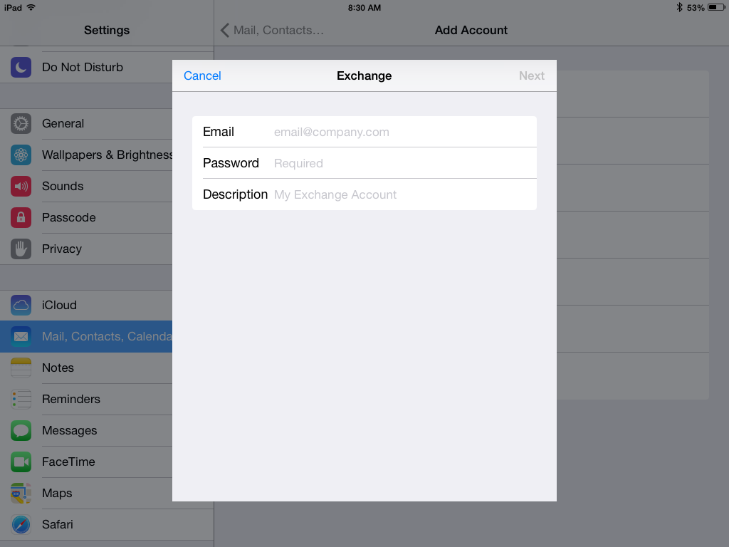
  - Email server address is: autodiscover.washoeschools.net
  - Input email address, username, password, and if required domain (washoeschols.net), select Next
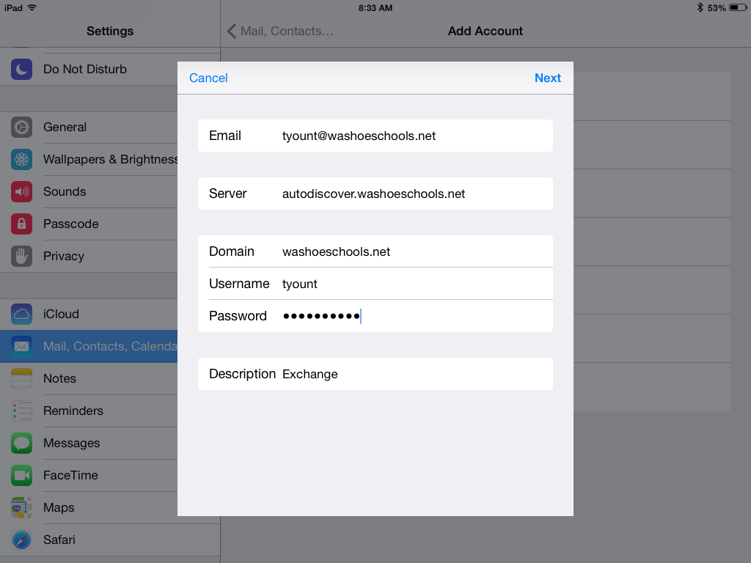
- When prompted, ensure Mail is on. Others are optional.
- Select Save

