Posting High School Progress GradeTip Sheet
Path: Campus Instruction > Grade Book
Open the Grade Book
Select a Section for posting Progress Grade
Select the Semester Grade Task (this task is used for posting all High School grades)
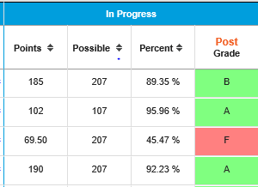
Click on POST located above Grade on the In Progress section of the grade book.

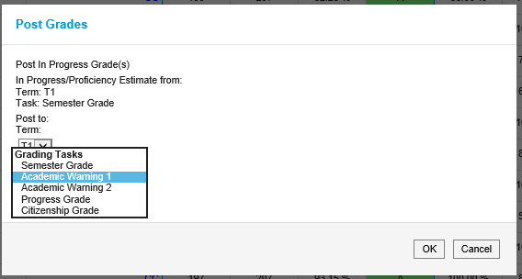

The post grade window opens.
This window shows the Source and Destination of the grades you are posting. Destination -Progress Grade (not Academic Warning 1)
The Source will be Semester Grade.
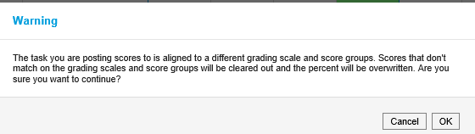
Change the Destination to Progress Grade.
Click on OK
The following WARNING will appear. Click OK
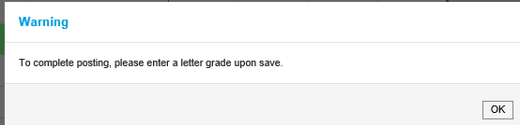
The next WARNING appears. Click OK

Notice that the grade book is now displaying the Progress Grade task.
Click on the cc next to the posted Progress Grade to add a Canned Comment.
If you do not see the cc next to the posted grade, open the Settings Tab and under Preferences flag the option Used Canned Comments.
Once grades are posted and canned comments have been added, click on as the final step to save the posted grades and canned comments.

