Career Center/Laptop Cart/Computer Lab Reservation Instructions

- If you haven’t already you need to add the different calendars to your Outlook. Start by clicking on the Open Calendar Icon and select from address book in the drop down menu
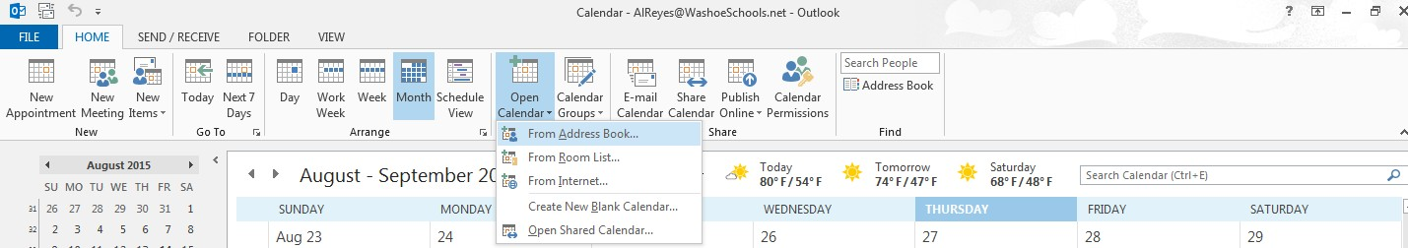

- Type in “Wooster” in the box that pops up. You will see “Wooster HS A13 Lab” “Wooster HS Career Center Lab” and when you scroll down a little you will see “Wooster HS Laptop Cart AB” and “Wooster HS Laptop Cart CD”

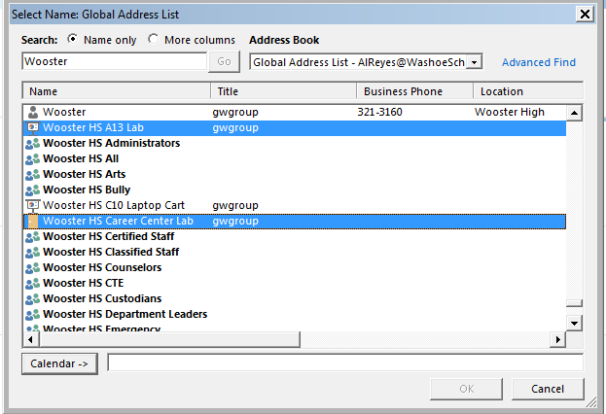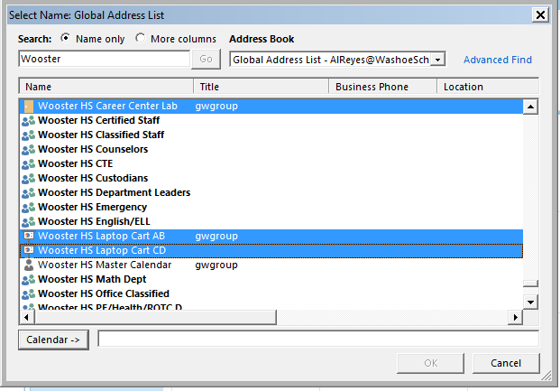

- Click on each lab and then click on the calendar icon. Once all the labs are listed next to the calendar icon click ok

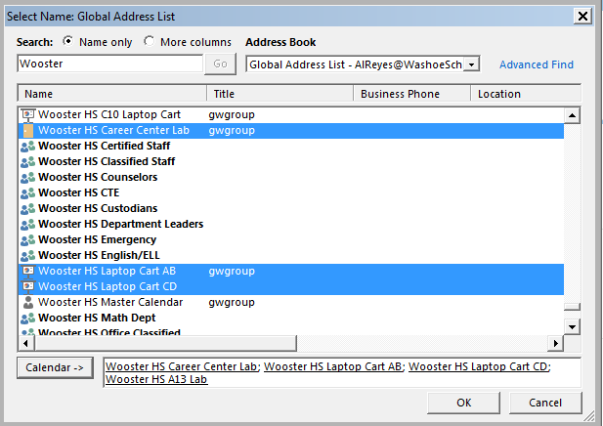

- Depending on your view settings you will now see something like this. If your calendar looks different that is because you have different view settings. To get my calendar to look like this I have the left bar expanded and use the schedule view setting. With this setting you get to choose what calendars you want to look at. So if you know you just want to use laptops you can uncheck the other boxes and you would just see the laptop cart schedule.
Those of you who are professional lab schedulers will note that the calendar looks way different this year. Instead of making you all go in and create appointments we have prescheduled every period on here.
Now you all can see if a period is open or if it is already reserved by a staff member.
To reserve a lab email (RMOORE@washoeschools.net ), or (gmartinez@washoeschools.net) with the date, lab, and periods you would like to reserve.
Because all the periods are already scheduled on the calendar if you try to request a meeting/appointment the calendar will automatically deny your request and we won’t get a notification that you were trying to schedule so please don’t do this.

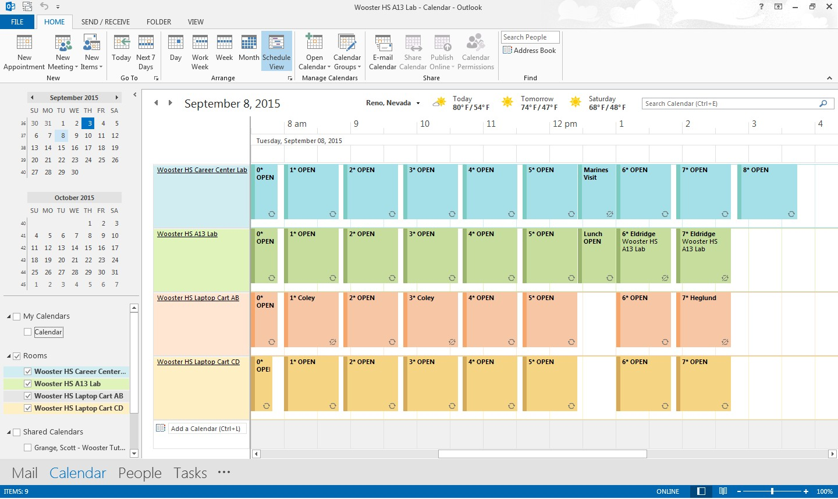

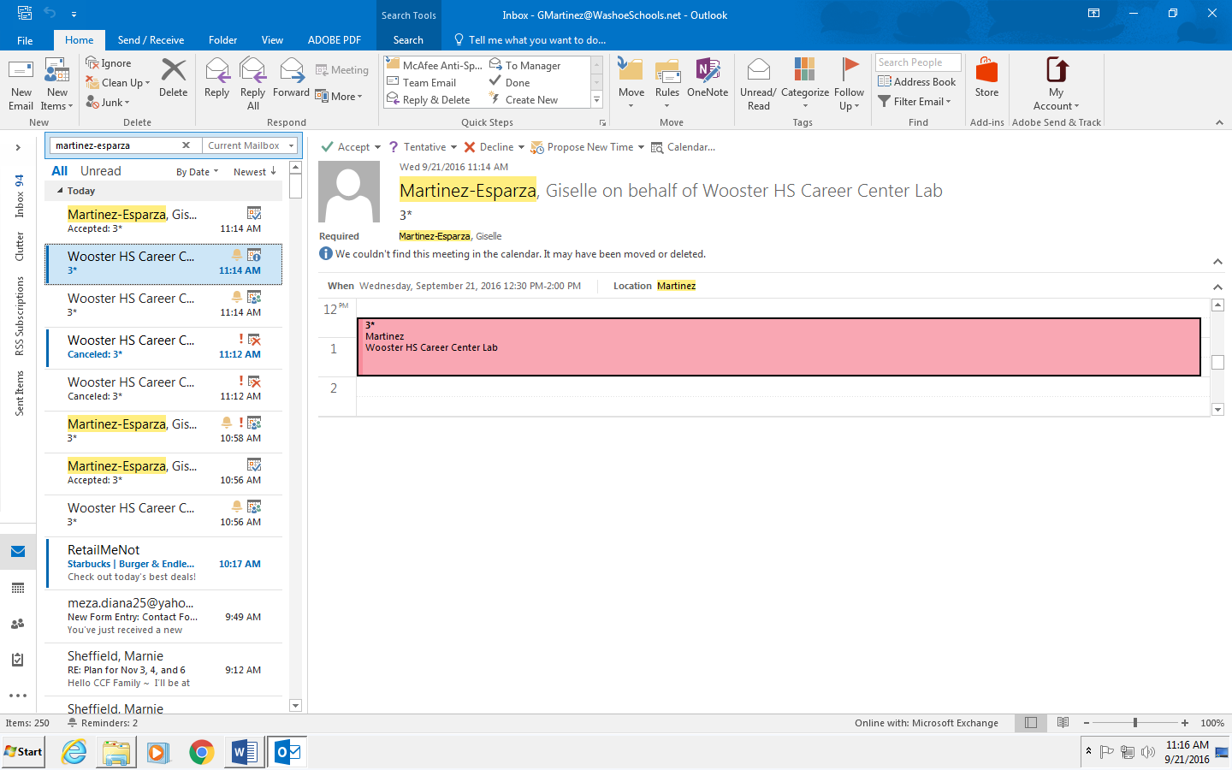
When we have received your reservation request and input it on the calendar you will receive an email like this:

If you accept the request you will have the reservation on your personal calendar but if you don’t your appointment will still stay on the calendar (no more disappearing lab reservations!)
If you guys have any questions or need help adding the calendars give us a call.
Giselle Martinez ext:37183
Rodger Moore ext.: 37113

