Posting Semester Grades

- Choose a course from the drop down menu

- Click on “gradebook” under “Instruction” in IC
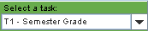
- Make sure that the Task selected is “T1 – Semester Grade”
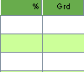
- Right click in the green area under the % or grade column heading

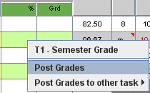
- Choose “Post Grades”

- Your grades will transfer from
the yellow column, to the green column.

- Click “SAVE”

- Repeat for your other classes!

Adding Comments and Adjusting Grades
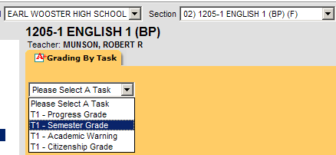
- Click on “Grading by Task”, found under “Instruction”

- Choose a class from the drop down menu, then choose “T1-Semester Grade”

- Changing a grade: If you have a student on the edge, say 89.9%, and want to bump up the grade, or if you have a student failing due to 121 attendance and need to change the grade to failing, do this: Click on the drop down menu next to the student and select the adjusted grade.
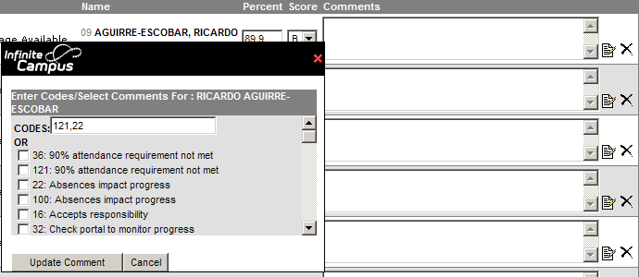
- Adding a comment: Click on the comment icon and either type in the grade code(s), separated by a comma, or click on the appropriate comment from the list. Only 3 comments will show on the report card; all comments will show on the parent portal.
Posting Citizenship grade on next page
- Click “SAVE”, then repeat for all classes

Posting Citizenship Grades

CITIZENSHIP GRADE
Choose a course on the drop down menu.

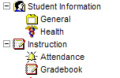

Go to Gradebook

In the Task drop down list choose Citizenship Grade for the term to post. Right click with the mouse in the green area under the % or Grade column heading.
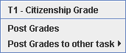
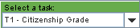

You will get this window.

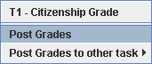
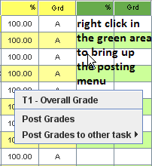

Choose Post Grades.

Grades will appear in the green column transferred from the yellow column. If there are no grades in the yellow column, check the Troubleshooting Posting Grades and the Gradebook page in this manual.

Choose Save. Repeat the same process for the remaining sections.

