**Printing Semester Grades**

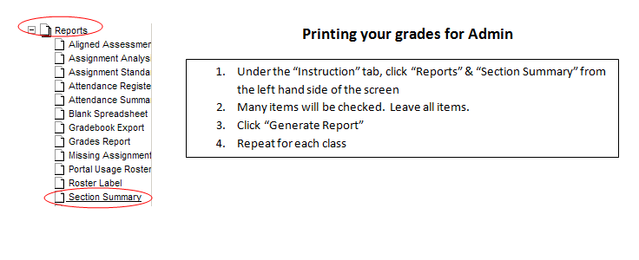

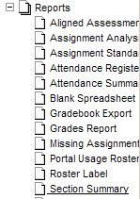**Printing your grades for Admin**

1. Under the “Instruction” tab, click “Reports” & “Section Summary” from the left hand side of the screen
2. Many items will be checked. Leave all items.
3. Click “Generate Report”
4. Repeat for each class