MYP Gradebook settings—Start in settings….click on “Grade Calc Options”
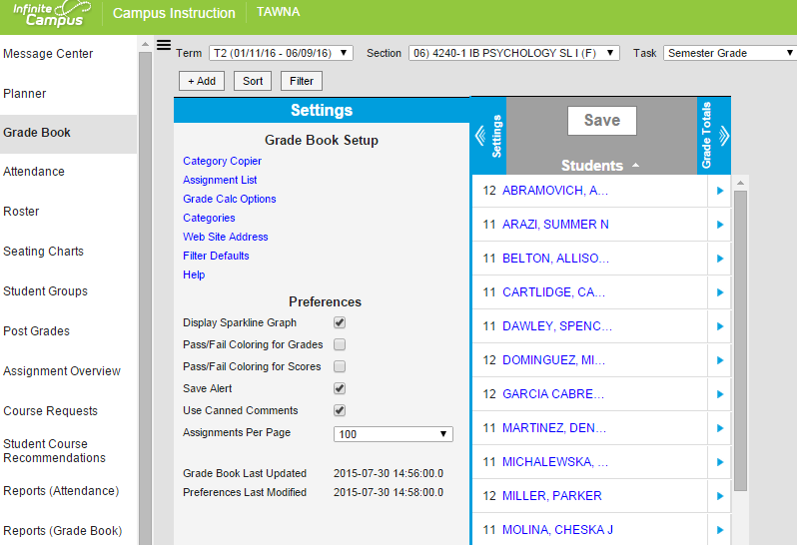
Click “Show all!” ---Look for MYP Semester Grade---Select MYP 1-7-----YOU MUST DO THIS FOR EVERY CLASS.
CHECK BOX IF YOU WEIGHT YOUR GRADES
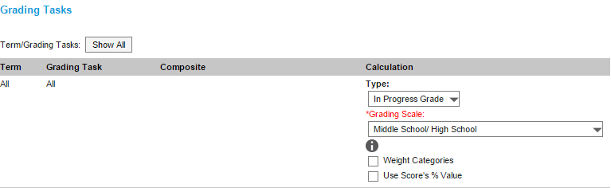
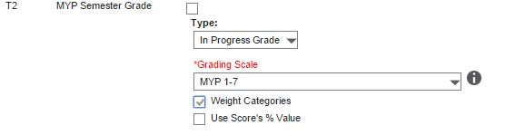
ALL YOUR OTHER GRADING TASKS MUST BE SET TO “MIDDLE SCHOOOL/HIGH SCHOOL!---only MYP SEMESTER GRADE WILL USE THE MYP SCALE!

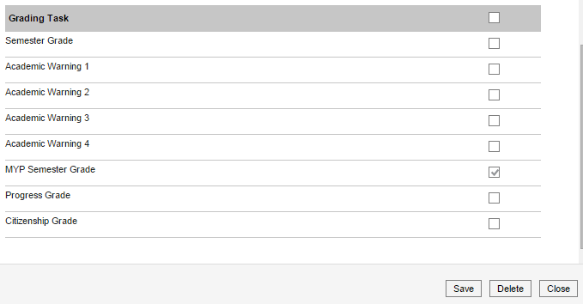
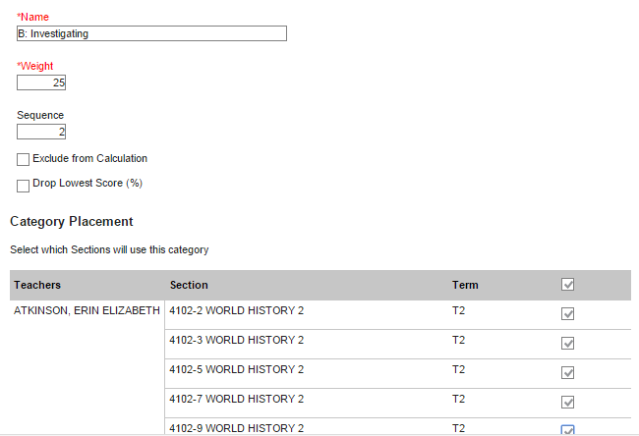
MYP Categories –4 of them set to 25% each (LISTED BY SUBJECT ON NEXT PAGE)
BACK IN SETTINGS----CLICK ON CATEGORIES
No MYP categories in semester grade, calculate separately
Any 9th or 10th grade class

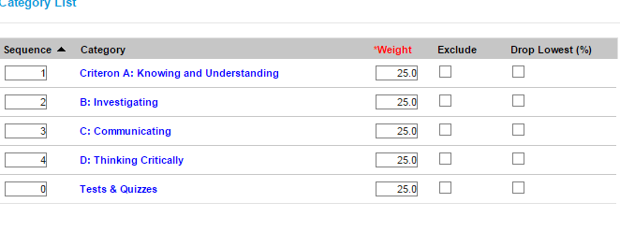
All categories will be listed here but will only appear in either semester or MYP gradebook, not both

What are the 4 Assessment Criteria for each class?
Subject Area | Assessment Criteria  (each criterion is scored 1-8) | Possible examples of assessments meeting criteria
Arts | A. Knowing and Understanding  B. Developing Skills  C. Thinking Creatively  D. Responding | - Selection from developmental workbook  - Representation of finished artwork/performance (including evidence of preparation of underlying theory)
English: Language and Literature | A. Analyzing  B. Organizing  C. Producing Text  D. Using Language | - Essay (literary, argumentative, persuasive, or analytical)  - Oral presentation response to literature  - Creative writing piece (dramatic scene, poetry, story)
Language Acquisition (Spanish, French or Chinese) | A. Comprehending spoken and visual text  B. Comprehending written and visual text  C. Communicating in response to spoken, written and visual text  D. Using language in spoken and written form | - Interactive oral tasks  - Reading comprehension task  - Writing tasks
Social Studies: (Individuals and Societies) | A. Knowing and Understanding  B. Investigating  C. Communicating  D. Thinking Critically | - Oral presentation on an investigation  - Document analysis/Source Evaluation
Mathematics | A. Knowing and Understanding  B. Investigating patterns  C. Communicating  D. Applying mathematics in real-life contexts | - Classroom test  - Mathematics investigation  - Real life-problem application with reflection
Physical Education | A. Knowing and Understanding  B. Planning for performance  C. Applying and performing  D. Reflecting and improving performance | - Evidence of student’s composition and performance  - Written work illustrating use of PE terminology  - Reflection of group performance
Science | A. Knowing and Understanding  B. Inquiring and designing  C. Processing and evaluating  D. Reflecting on the impacts of science | - An experimental investigation  - Unit test  - Written essay applying science in society with documented sources
Design (Technology) | A. Inquiring and analyzing  B. Developing ideas  C. Creating the solution  D. Evaluating | - Application of the design cycle to create a final product such as a webpage  - Reflection on the design cycle process

Adding Assignments
You can (if you want), add an assignment into both MYP and semester grades for different point values so it counts for both. MYP grades are always out of 8

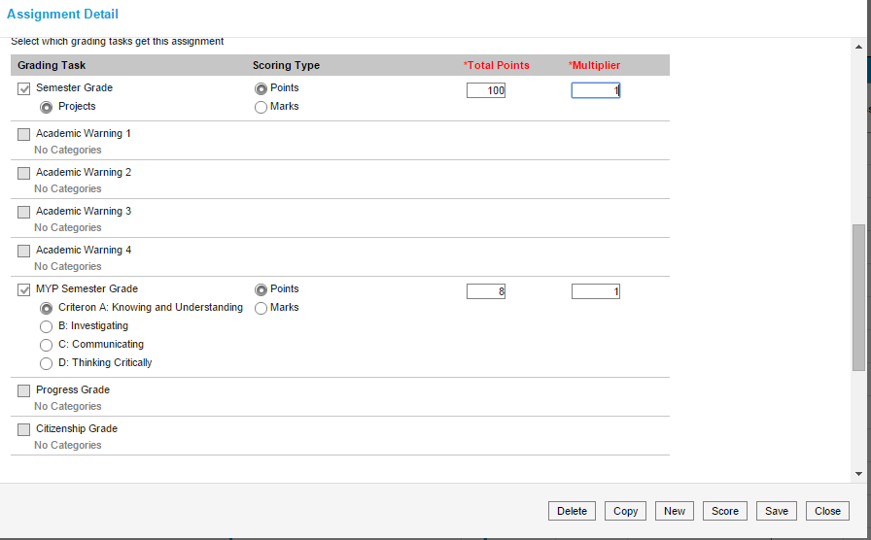

MYP is always out 8 points possible

